Step 1:-go to the Jenkins ->select free style job->put name for job “first”

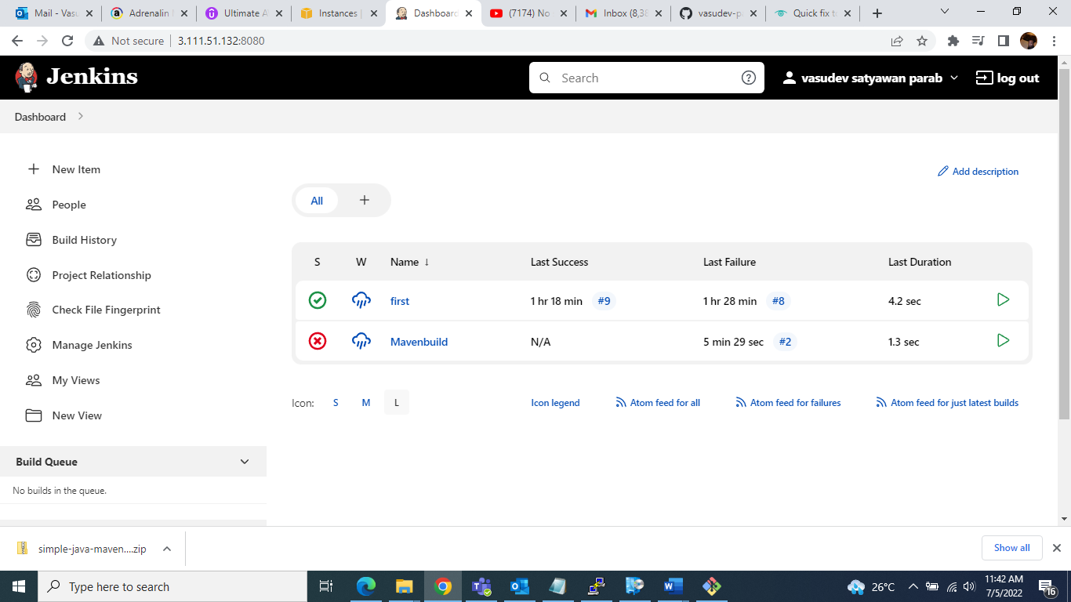

Step2:-go to the general select “github project” option ->put the URL u r GITHUB PROJECT For example

” https://github.com/vasudev-parab/shlok-hotel”

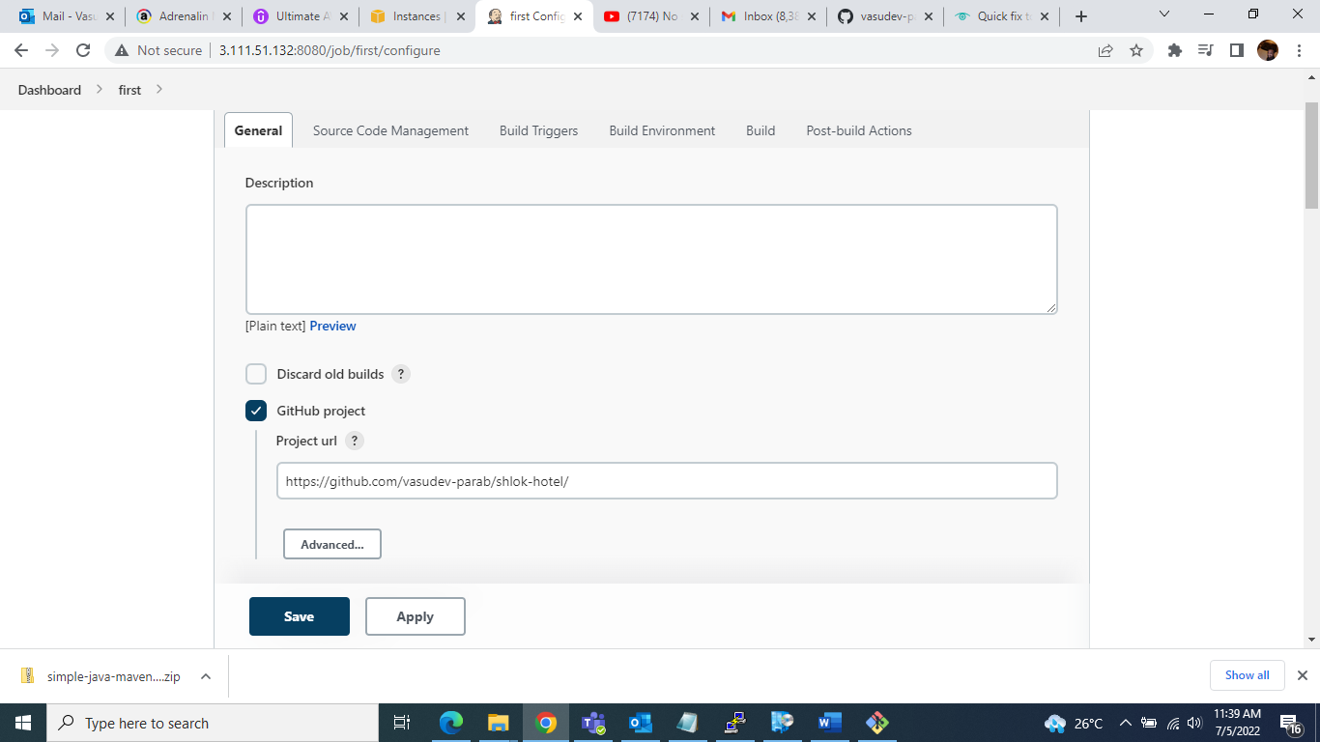

Step3:-go to the source code management and select “git” option ->then put the Repository url example <https://github.com/vasudev-parab/shlok-hotel.git> ->next add credentials for your GitHub account (example. GitHub account user name and password)

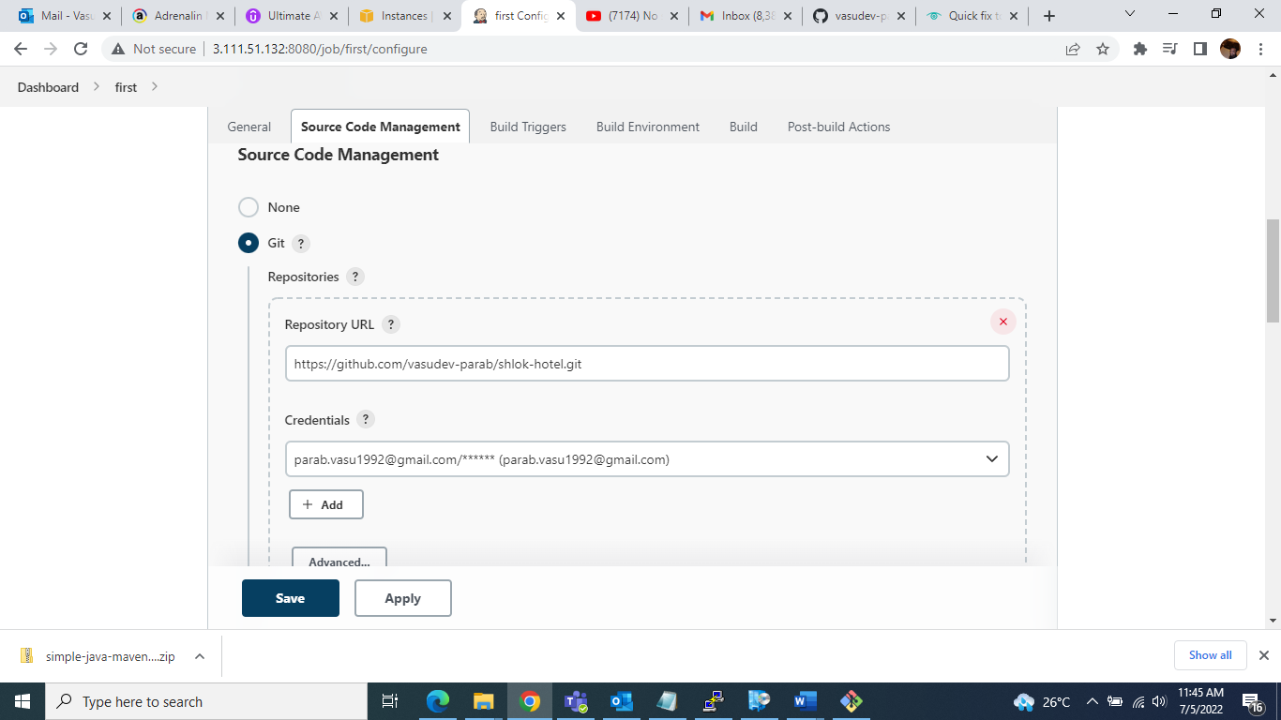

Step4:- select your Github account project Branch “Master”

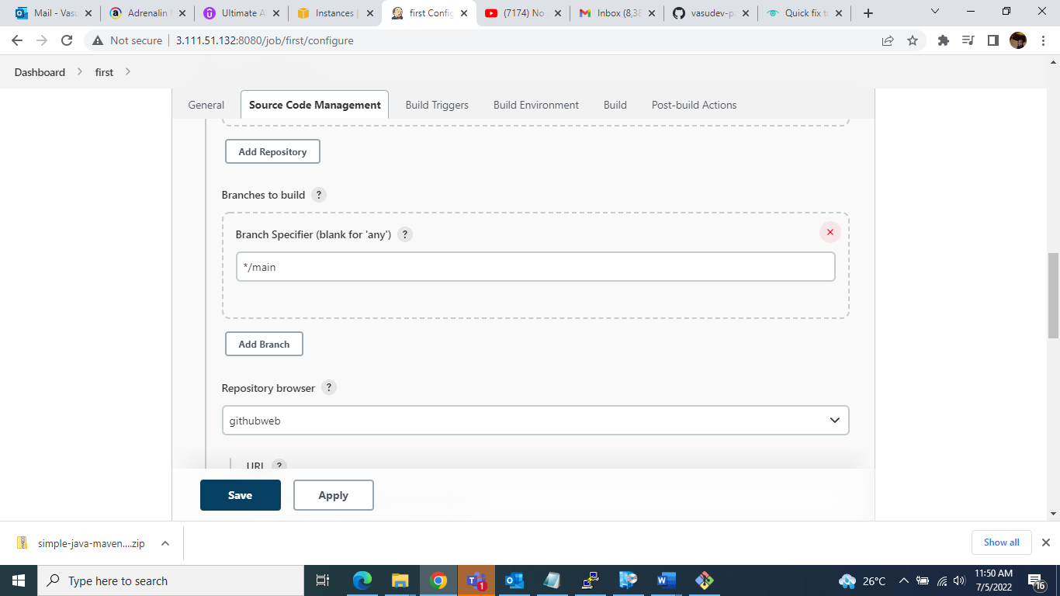

Step5: -then after click on Apply and save….

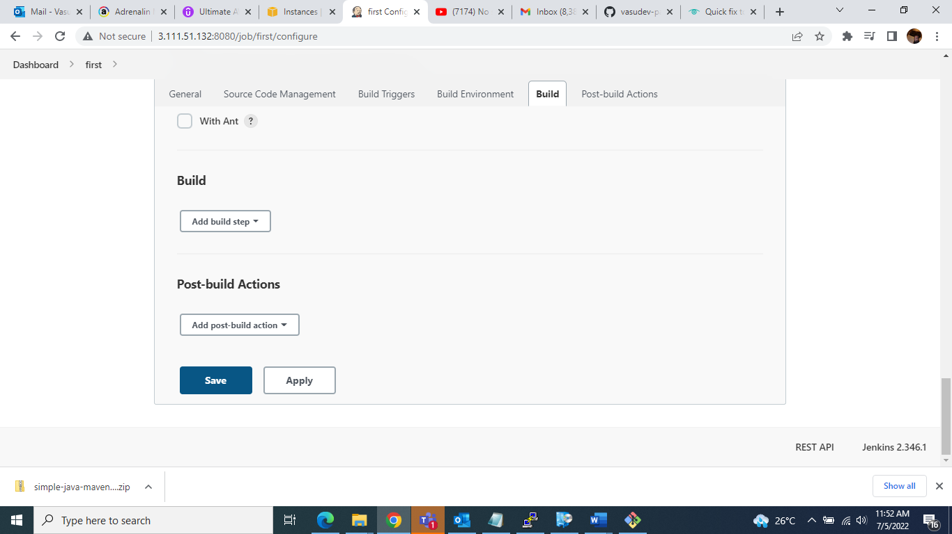

Step 6:- then click on Build now…..

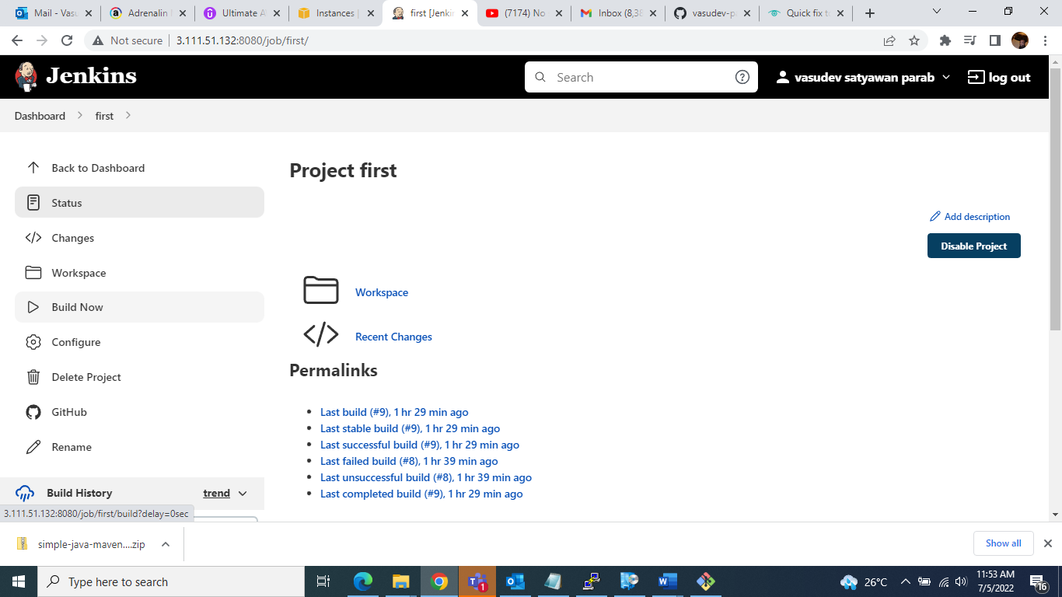

Step 7 :-suppose you are getting this arror….

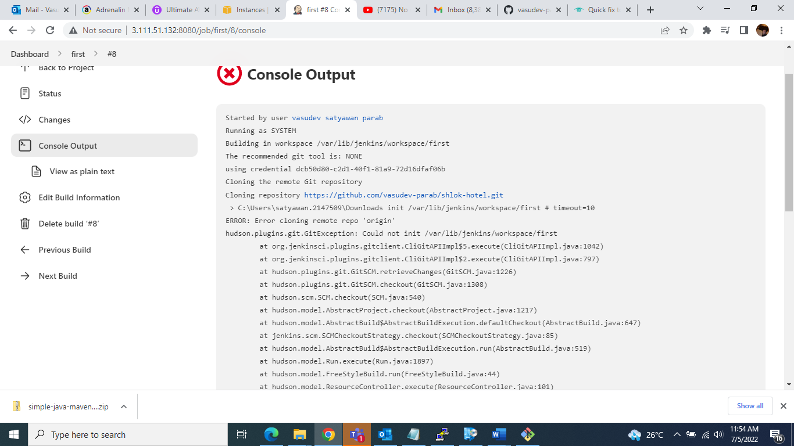

Step 8 :-getted error after go to the Jenkins dashboard-> go to the manage Jenkins and select

“global tool configuration”->then select option “GIT” “AND PUT THE NAME AND GIT PATH”-> THEN CLICK ON SAVE AND APPLY……

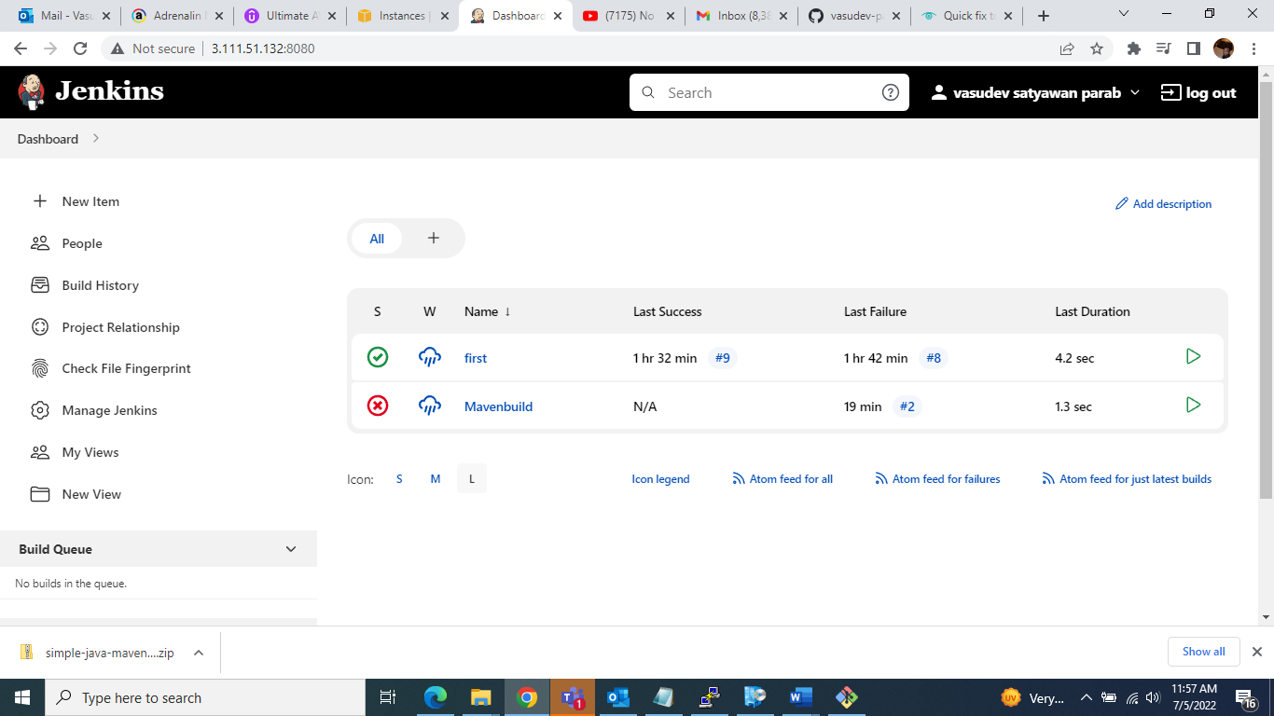

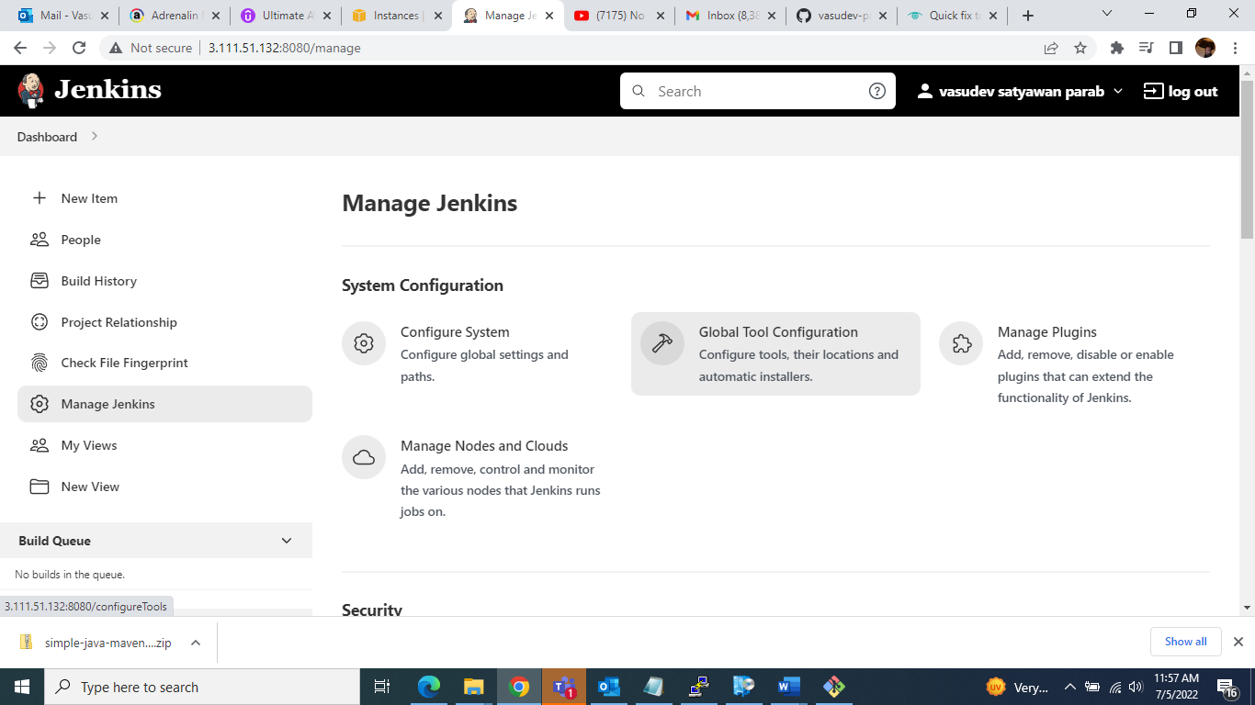

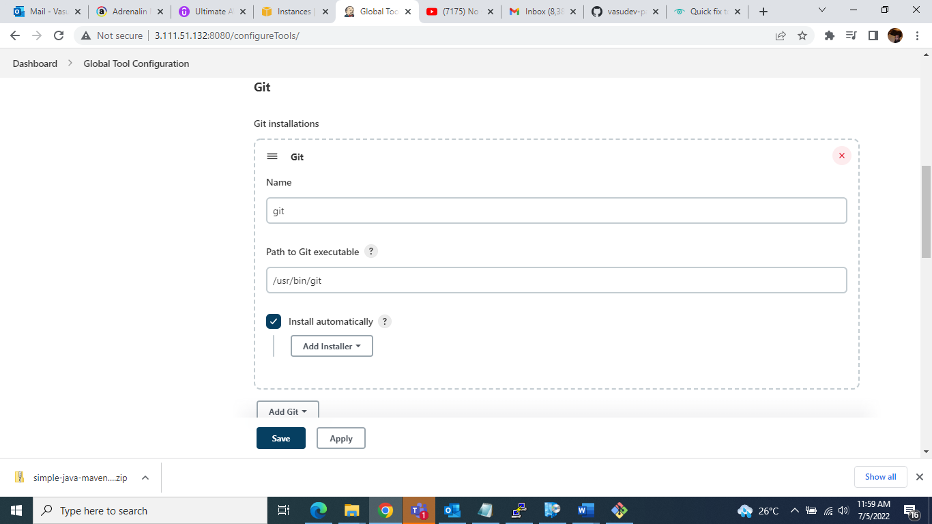

Step9 :- Also check git path in your putty session……

[ec2-user@ip-172-31-8-219 ~]$ which git.......(check git path)

Output:-> /usr/bin/git

Installation Git……

Sudo yum install git

[Vasudev@jenkins ~]$ sudo yum install git

Loaded plugins: langpacks

Resolving Dependencies

--> Running transaction check

---> Package git.x86_64 0:1.8.3.1-23.el7_8 will be installed

--> Processing Dependency: perl-Git = 1.8.3.1-23.el7_8 for package: git-1.8.3.1-23.el7_8.x86_64

--> Processing Dependency: perl(Term::ReadKey) for package: git-1.8.3.1-23.el7_8.x86_64

--> Processing Dependency: perl(Git) for package: git-1.8.3.1-23.el7_8.x86_64

--> Processing Dependency: perl(Error) for package: git-1.8.3.1-23.el7_8.x86_64

--> Running transaction check

---> Package perl-Error.noarch 1:0.17020-2.el7 will be installed

---> Package perl-Git.noarch 0:1.8.3.1-23.el7_8 will be installed

---> Package perl-TermReadKey.x86_64 0:2.30-20.el7 will be installed

--> Finished Dependency Resolution

Dependencies Resolved

========================================================================================================================================================================

Package Arch Version Repository Size

========================================================================================================================================================================

Installing:

git x86_64 1.8.3.1-23.el7_8 base-openlogic 4.4 M

Installing for dependencies:

perl-Error noarch 1:0.17020-2.el7 base-openlogic 32 k

perl-Git noarch 1.8.3.1-23.el7_8 base-openlogic 56 k

perl-TermReadKey x86_64 2.30-20.el7 base-openlogic 31 k

Transaction Summary

========================================================================================================================================================================

Install 1 Package (+3 Dependent packages)

Total download size: 4.5 M

Installed size: 22 M

Is this ok [y/d/N]: y

Downloading packages:

(1/4): perl-Error-0.17020-2.el7.noarch.rpm | 32 kB 00:00:00

(2/4): perl-Git-1.8.3.1-23.el7_8.noarch.rpm | 56 kB 00:00:00

(3/4): perl-TermReadKey-2.30-20.el7.x86_64.rpm | 31 kB 00:00:00

(4/4): git-1.8.3.1-23.el7_8.x86_64.rpm | 4.4 MB 00:00:00

------------------------------------------------------------------------------------------------------------------------------------------------------------------------

Total 7.1 MB/s | 4.5 MB 00:00:00

Running transaction check

Running transaction test

Transaction test succeeded

Running transaction

Installing : 1:perl-Error-0.17020-2.el7.noarch 1/4

Installing : perl-TermReadKey-2.30-20.el7.x86_64 2/4

Installing : perl-Git-1.8.3.1-23.el7_8.noarch 3/4

Installing : git-1.8.3.1-23.el7_8.x86_64 4/4

Verifying : git-1.8.3.1-23.el7_8.x86_64 1/4

Verifying : 1:perl-Error-0.17020-2.el7.noarch 2/4

Verifying : perl-Git-1.8.3.1-23.el7_8.noarch 3/4

Verifying : perl-TermReadKey-2.30-20.el7.x86_64 4/4

Installed:

git.x86_64 0:1.8.3.1-23.el7_8

Dependency Installed:

perl-Error.noarch 1:0.17020-2.el7 perl-Git.noarch 0:1.8.3.1-23.el7_8 perl-TermReadKey.x86_64 0:2.30-20.el7

Complete!

[Vasudev@jenkins ~]$ which git

/usr/bin/git

Define git path in Jenkins ->manage Jenkins-> global tool configuration